|  |  |  |
| --- | --- | --- |
|  | | |
| **Welcome to ‘The Pulse’** | **The Pulse**  “The heart of God  to the heart of the community”  **November 2017 Issue** |

The Pulse is newsletter produced by the Ellesmere Cooperating Parish. We are three congregations that make up a rural parish in the south-eastern part of the Selwyn District of Canterbury, NZ.

Our congregations gather folk from Leeston, Southbridge, Dunsandel and Brookside, drawing people from all walks of life, with a high proportion involved in farming or associated services. Our main worship centres are at St. David’s, Leeston and Trinity, Dunsandel. Our Brookside congregation has shared use of St. Luke's Anglican Church at Brookside.

**Purpose Statement:** To spread the good news of Jesus by committing ourselves to work and worship together, to love and care for one another, and to be of value to God in our community.

To find out more about the Ellesmere Cooperating Parish, please take the time to visit us on line at [www.churchatellesmere.org.nz](http://www.churchatellesmere.org.nz/)

We hope you enjoy this issue of The Pulse.

Your newsletter was delivered by:

…………………………………………………………….

Phone: …………………………..............................

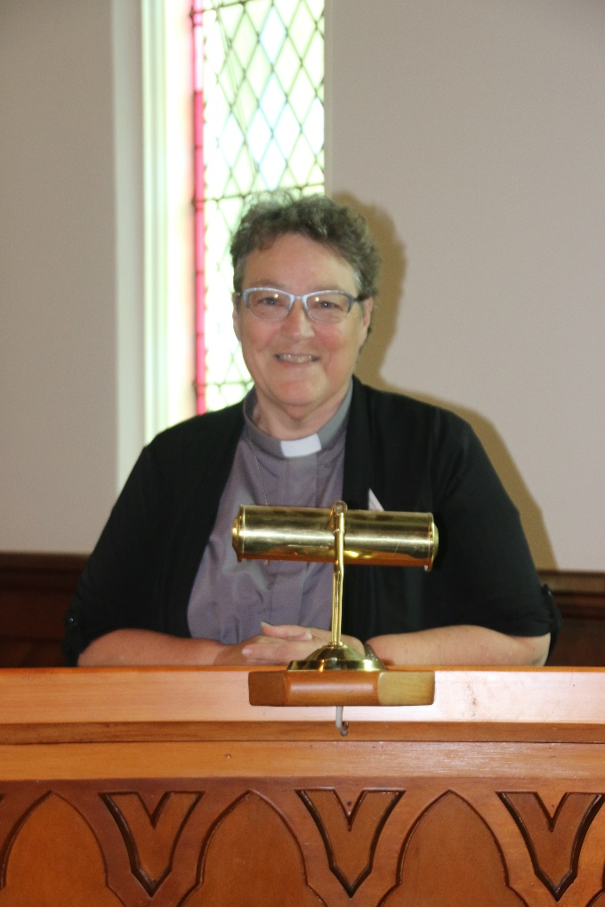**Reflection from Rev. Heather Kennedy**

It is lovely to see the changes to the weather and the gardens now that Spring is here. I am sure that like me you are all feeling a lot more positive and energised with the warmth and blue skies. It is the time of the year when we all acknowledge the wonder of the world God created. As we all start to plant our summer veges, make plans for the Advent season and maybe look forward to a holiday away somewhere, we also feel more enthusiastic about making plans for the church and the life of the parish.

It has been encouraging to see a sense of commitment to the parish, not only in the return of the ‘Count Me In’ forms, but also in the activities being planned for the Christmas season. I urge you all to check out the details in the list at the end of this newsletter. I wish you all well as we approach the season of Advent in the Church Calendar and the happy celebrations for the birth of our Lord and Saviour, God’s son, Jesus Christ.

**Parish Council Report from Rev. Heather Kennedy – October 2017**

During October a few of us gathered with residents at Ellesmere Hospital to partake of a short Holy Communion service. If anyone who is unable to attend church wishes to have Communion at home, this can be provided. I was also able to visit some members who have not been well. Please let me know if you would like me to visit, for any reason.

Along with Noel Dalley and Don Clearwater, I attended the Presbytery Gathering in Timaru 6-7 October and appreciated the content of the resourcing sessions, the inspirational presentations and the opportunity to network and chat with others.

• Of particular note were snippets shared by the parishes in and around Timaru, with projects they are involved in, challenges they are facing and, in many cases, over-coming.

It was emphasised that each was in a unique setting and what they shared was not a ‘go-and-do-likewise’ model for other parishes.

• A presentation by Knox Centre for Ministry focussed on themes relating to Faith, Community Life, Outreach, Leadership and Church Form and where the potential was in each of these areas for the provision of training, resourcing and equipping for parishes. This provoked an in-depth discussion and the collecting of many suggestions to be investigated by Knox Centre.

• Another discussion was also held on the role of the PCANZ Assembly Moderator, which follows on from many of the proposals which have been presented in recent years at Assembly, seeking a way to make the Moderator’s role clearly defined as the church looks to a future which will see the Moderator serve in a wider context than in the past.

I also attended a very interesting seminar on ‘Building the Church – For Today and Tomorrow’ at Cashmere Presbyterian Church on Tuesday 17 October. Topics presented by Christian Savings, Carey Centre and Laidlaw College included ‘Mission and Social Activism’, ‘Faith in Action’, ‘Being Financially Healthy’, ‘Strategic Planning’ and ‘The Next Generation of Church Buildings’. The presenters were all of a very high calibre and informative, with a lot of encouragement and food for thought.

The ‘Count Me In’ Membership Forms responses have come in and been collated by the Pastoral Care committee. The response has been quite good, with some follow-up yet to do. Hopefully the Parish Roll will be formally recorded by the end of the year. Some responders requested to become members of the parish and we hope to formally welcome these people to the parish as part of the Covenant Service on Sunday 4 February 2018.

I attended the St. David’s Fellowship group lunch and then the Trinity Fellowship group meeting on 12 October. Their guest speaker was Rev. Sandra Wright-Taylor, a Presbyterian Minister and Burwood Hospital Chaplain. Her talk was very interesting, but sadly the slide show didn’t show very well. The computers and data-projectors in the parish seem to be in need of updates and maintenance. The Worship Committee is suggesting that programmes be purchased that will allow for better use of the computers and for Power Point Presentations to be screened. It may even be that the laptops have reached a use-by date?

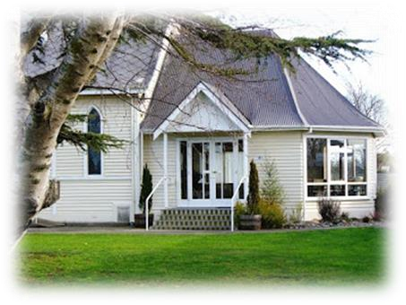***News from the Leeston Sector Group***

***-from Frances Baylis***

Sector members remain the same except we welcome Kathy Steel and value her contributions.

During August we had nice warming soups after our Sunday service, this was a pleasant lunch.

There have been positive comments about the shed extension, this now gives Kathy and Anne more room to display garments that are for sale.

The lawn-mower now has a garden shed of its own and there is another shed at the front of the church grounds for the Farmers’ Market to store their equipment.  
At our October meeting there were several maintenance matters discussed, to address these there is a working bee planned for Wednesday 8th November at 4.30   Many hands make light work.

The hall and Sunday School room have had a tidy up already.  
We wish to thank Peter and Jill Lemon for tackling the macrocarpa hedge. It now looks very tidy.

Pizza Cafe is continuing thanks to Lynda; recently a group of young people went to an Arise Church service in Christchurch.

Several church members filled shoes boxes for Operation Christmas Child.

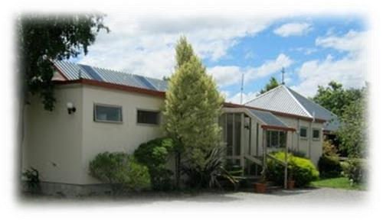***News from Dunsandel Sector group***

***-from Robbie Stewart***

*At the Annual Congregational Meeting in July we welcomed Jill Chamberlain onto Sector. We also decided to continue with our CAFÉ CHURCH services.*

*Bruce Morris (TEAR FUND) spoke at a crowded Trinity for the Parish Service on July 30th. Rev. Don Clearwater (6th August) and Rev. Kathryn Walters (13th August) filled in for Heather’s absence and were excellent, as always. We had a good number for our Sermon and Soup Sunday on 20th August. Trinity was rocking for another FIRE PARTY organise by Heather Gullery on Saturday September 2nd. Trinity Hall was packed. Lots of flowers adorned Trinity for both Father’s Day Service (3rd September) and Spring Sunday (10th September). Rev. Kathryn Walters lead our Service on 8th October and Rev’d. Nelson Kennedy (retired Anglican Vicar from Rolleston) took the Anglican Service on 15th October. Numbers attending Sunday Services have remained fairly steady. With the tremendous Spring growth, we’re struggling to keep on top of the grass surrounding Trinity. Blossom in and around Trinity Grounds has been spectacular.*

***And now for something funny…***

An old $5 note and an even older $50 arrive at a Federal Reserve Bank to be retired.

"I've had a pretty good life," the $50 says. "I've been to Vegas, the finest restaurants in New York, and even on a Caribbean cruise."

"You did have an exciting life!" the $5 says.

"Where have you been?" the $50 asks.

"Oh, I've been to the Methodist church, the Baptist church, spent some time with the Lutherans..."

"Wait," the $50 interrupts. "What's a church?"

***The Mission Shed***

An update on The Shed’s activities – October 2017.

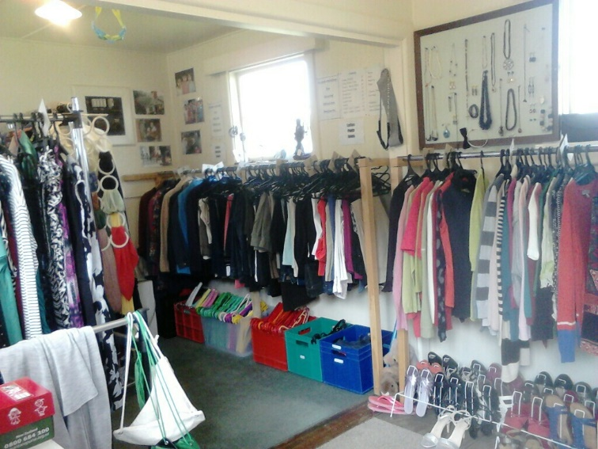The major change since the last update is the extra space allocated for the Mission Shed’s use. After much discussion and investigation, the decision was reached to minimize the office space and build a partition wall giving the Shed an extra room. The first week of July saw Ann and Kathy spruce up the room with a paint job before locating the various items of furniture and racks needed. It was business as usual the following Wednesday.

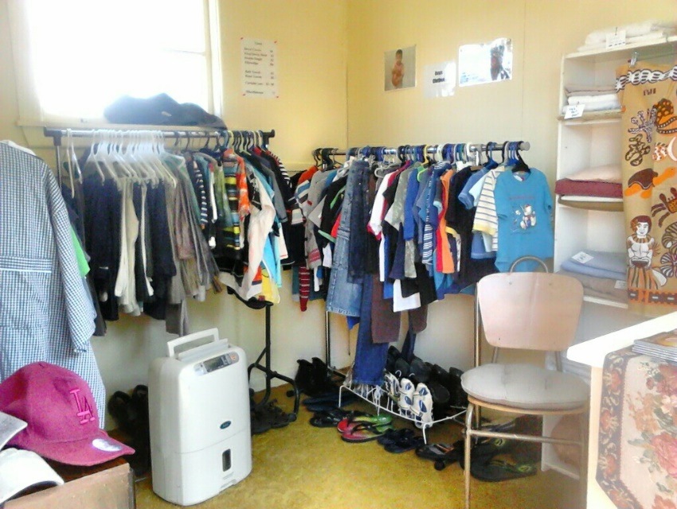With fresh appeal, a pleasant atmosphere and room to move there has been heaps of positive feedback from the community.

Contact is made with an interesting mix of people and this ministry requires a listening ear. This may be as near to crossing the threshold of a church as some come.

September sales have slowed but various equations can be factored in here. Opening hours are to be reviewed in the New Year, as being open during School Holidays was a trial period only.

Coinciding with the end of Summer/Winter Sales, time could be better utilized doing the time- consuming job of Stock Rotation.

Winter Stock sales for the month of August have tallied at $412.

Second and final payments for 2017 of $1,000 went out in September to both - Pastor Ablos in the Philippines &

- Qinghai Disabled Orphanages in China.

As a ministry the Group has been able to meet its budgeted target thanks mostly to the hard work and commitment of those involved and to a gracious and loving God who cares for all mankind.

The Shed’s involvement with Samaritans Purse Operation Christmas Child throughout September/October has resulted in six completed Shoeboxes.

We were invited to take part in Market Day’s 10th Anniversary on Saturday October 21st with the use of a Gazebo out front of the Church.

Thanks to those who recognise the Mission Shed as impacting on the community.

Information [suggested by a member of the public] including telephone contacts, have been added to the existing Church Website.

Advance notice - the W.M.P. Group to meet the last week in January 2018.

**News from St. David’s Friendship Group.**

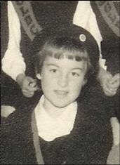In August several of our Members journeyed to Dunsandel to join with Trinity for their Combined Meeting. We enjoyed hearing Rev. Heather Kennedy telling us about her life’s journey. What an interesting life she has led from school days to a nursing career, family, much study of various subjects and then a year of Theological Study in Dunedin before entering the Ministry some 18 years ago. Thank you Heather for sharing your life story with us, we all feel we know you a little better.

Our September get-together was combined with Afternoon Fellowship Members in the Foyer, Hilary led Devotions, her theme “Food”. Our Speaker was Jim Kennedy, Rev. Heather’s husband. Jim entertained us, dressed appropriately in his Chef’s Uniform. As a child he loved cooking—as a 12 year old at a Catholic School in England he was allowed to join a 4th Form cooking class—all girls of course and from there he continued his love of cooking. After moving to NZ in the North Island, Jim continued in the Food Industry, until he and Heather moved to Dunedin in the late nineties, when he applied for and obtained a Chef’s position on the Fiordland Travel Cruise Ships on 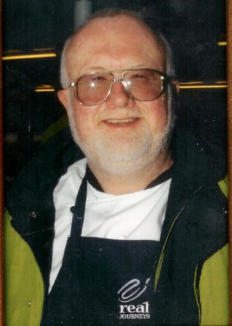Milford Sound. Jim spent 18 years as a Chef on ships in Milford Sound, catering for up to 500 passengers each cruise—usually am and pm cruises each day. What an amazing and responsible job requiring excellent organizational skills and food requirement skills. Members interest was shown by the many questions they asked. Thank You Jim.

October saw 12 Members, including one new Member travel to “Salmon Tales” at Rakaia for our lunch outing. All enjoyed their own choice of lunch after which we either enjoyed a browse in the Craft Shop or a stroll to the interesting little Gift shop in the Red Shed with its amazing range of gifts and treasures. We then drove on to Marie Johnson’s daughter, Karen Harcourt’s two-year-old House and Garden. The large lawn and garden are a work in progress, but already well established with Rhodos, trees and interesting plantings, along with some old farm implements from Peter’s family farm and other interesting bits and pieces. Karen welcomed us into their lovely new home looking up to the mountains and with many interesting features throughout, where we enjoyed afternoon tea and a chat.

Thank you Karen for your kind hospitality.

**St. David’s Afternoon Fellowship Report**

*In August we travelled to Dunsandel to join their Fellowship to hear speaker Heather Kennedy talk on her Christian life and education.*

*A very interesting talk from a very talented lady. Afterwards we had a beautiful afternoon tea, then purchased goods from their sales table.*

*A very successful raffle was held to raise funds for their group.*

*A lovely friendly afternoon was had by all, thank you Dunsandel.*

*In September we met in the church lounge with the Friendship group to hear Jim Kennedy share with us his life of cooking and serving others. Sometimes on land, cruise ships, and tourist liners. Jim looked very smart in his chef’s uniform.*

*Our October meeting was a finger food lunch held in the church lounge. After a short meeting we then had a friendly discussion on the future of our fellowship.*

**Southbridge Home Group**

Heather brings us some very interesting topics each month for us to discuss. In August, Heather was away, so Margaret Clearwater lead the group. In September we looked at racism and prejudice and in October we had a grumbling session (along with the Israelites!).

Ruth had a card for us to sign and leave a message for Pat Freeman, who now resides at a rest home in Rangiora. We will miss Pat’s singing and knowledge of remembering and reciting Bible verses.

***ELLESMERE COMMUNITY CARE ORGANISATION***

Once again we are collecting non-perishable goods and gifts – adults and children’s (unwrapped please) for ECCO to distribute around Ellesmere prior to Christmas. These may be brought to St. David’s, Leeston no later than 10th December. All will be gratefully received.

Lois Birkett

**How to avoid Brain Drain**

Studies from the US show that having a smartphone in the same room as you, restricts your brain power, even when the device is switched off. The research shows that sub-consciously thinking about your phone or struggling not to think about your phone creates a degree of ‘brain drain’. Switching it to silent isn’t enough to trigger full concentration and neither is putting it into a pocket or bag. To maximise your focus its best to leave your phone out of the room.

Supplied. From People’s Friend.

**Ellesmere Intercessory Prayer Group**

We have been meeting together every Tuesday evening at 7p.m. for the last 5 years at St. David's Church and once a month at Trinity Church in Dunsandel. Our group is made up of a mix of folks from various churches in the district. Our purpose is to worship and wait on the Lord for the leading of His Holy Spirit to pray for that which is on His heart. Over the years we have faithfully prayed for the various churches, organizations, schools and leaders in our district. We have had some wonderful answers to prayer from loved one's coming to salvation, the ill being restored to health, ministries growing and the tangible evidence of God's blessing manifesting in our communities.

When it comes to being a part of a prayer group, many people may think you have to be special or have a special gift for it, but that is not true. Anyone can pray – after all – don't we all know someone who needs the Lord's intervention in their lives? This is the real joy of being a part of a prayer group – to pray for those who need help and seeing the Lord's answers. We welcome all who would want to pray with us for the well-being of our communities and to see God's Kingdom plans and purposes come about in our district. Mandy Lotter

**Lifetouch Christian Ministries**

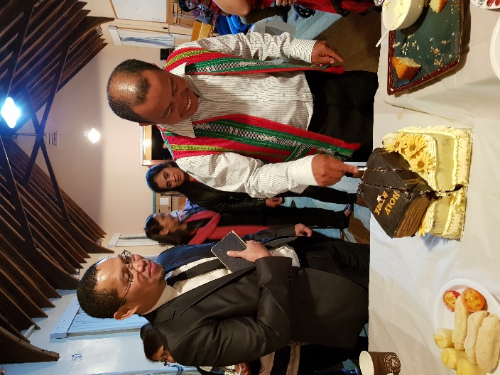It has been 6 years since Lifetouch Christian Ministries came into being. When our church was started nobody had a picture of what the Lord was about to do. We have grown spiritually and in numbers as well. Many had found their faith in Jesus Christ and we have seen how God changed people’s [lives. It](http://lives.it/) says in Philippians 2:13 "for it is God who works in you to will and to act in order to fulfil his good purpose”.

We recognize that it is not by our own making that we are able to be here, but God has purposed it. We are here because it is the will of God and it is God who has made it so, so that His good purpose can be fulfilled.

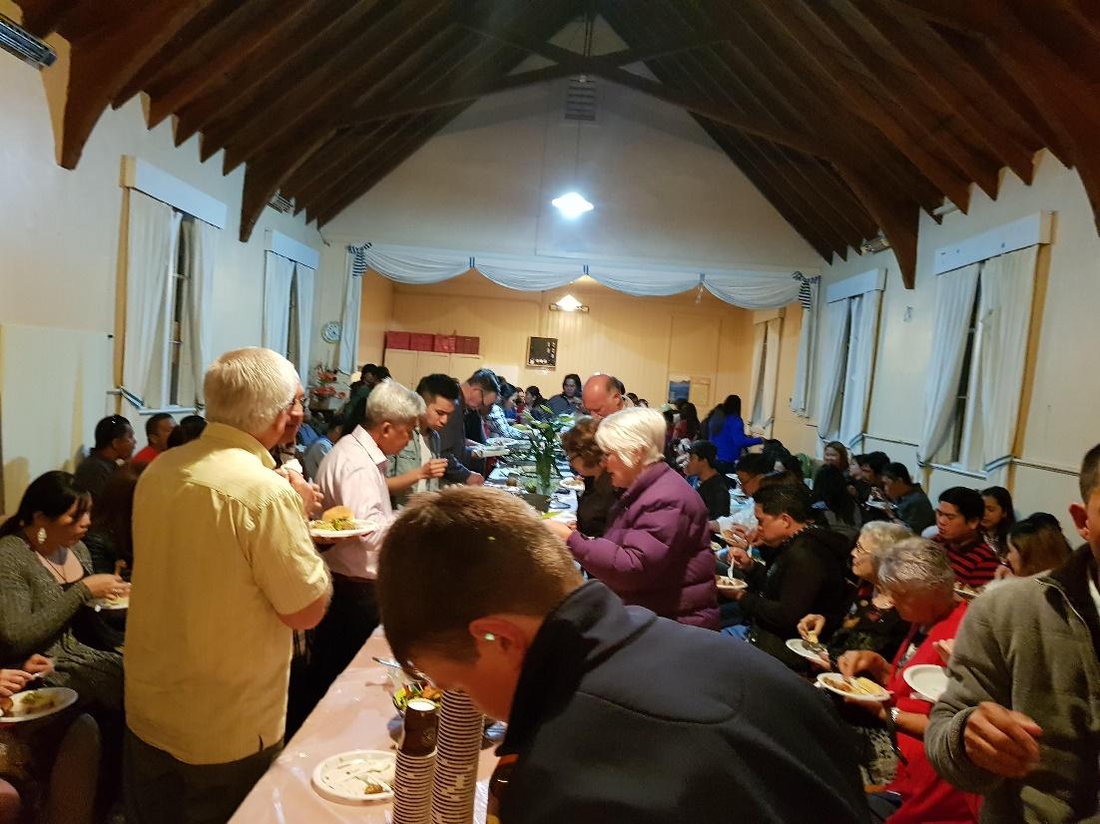We have all the reasons to Thank God and

celebrate our 6th year anniversary. Jesus Christ had been leading us all these years and we are all grateful from the bottom of our hearts for God’s faithfulness.

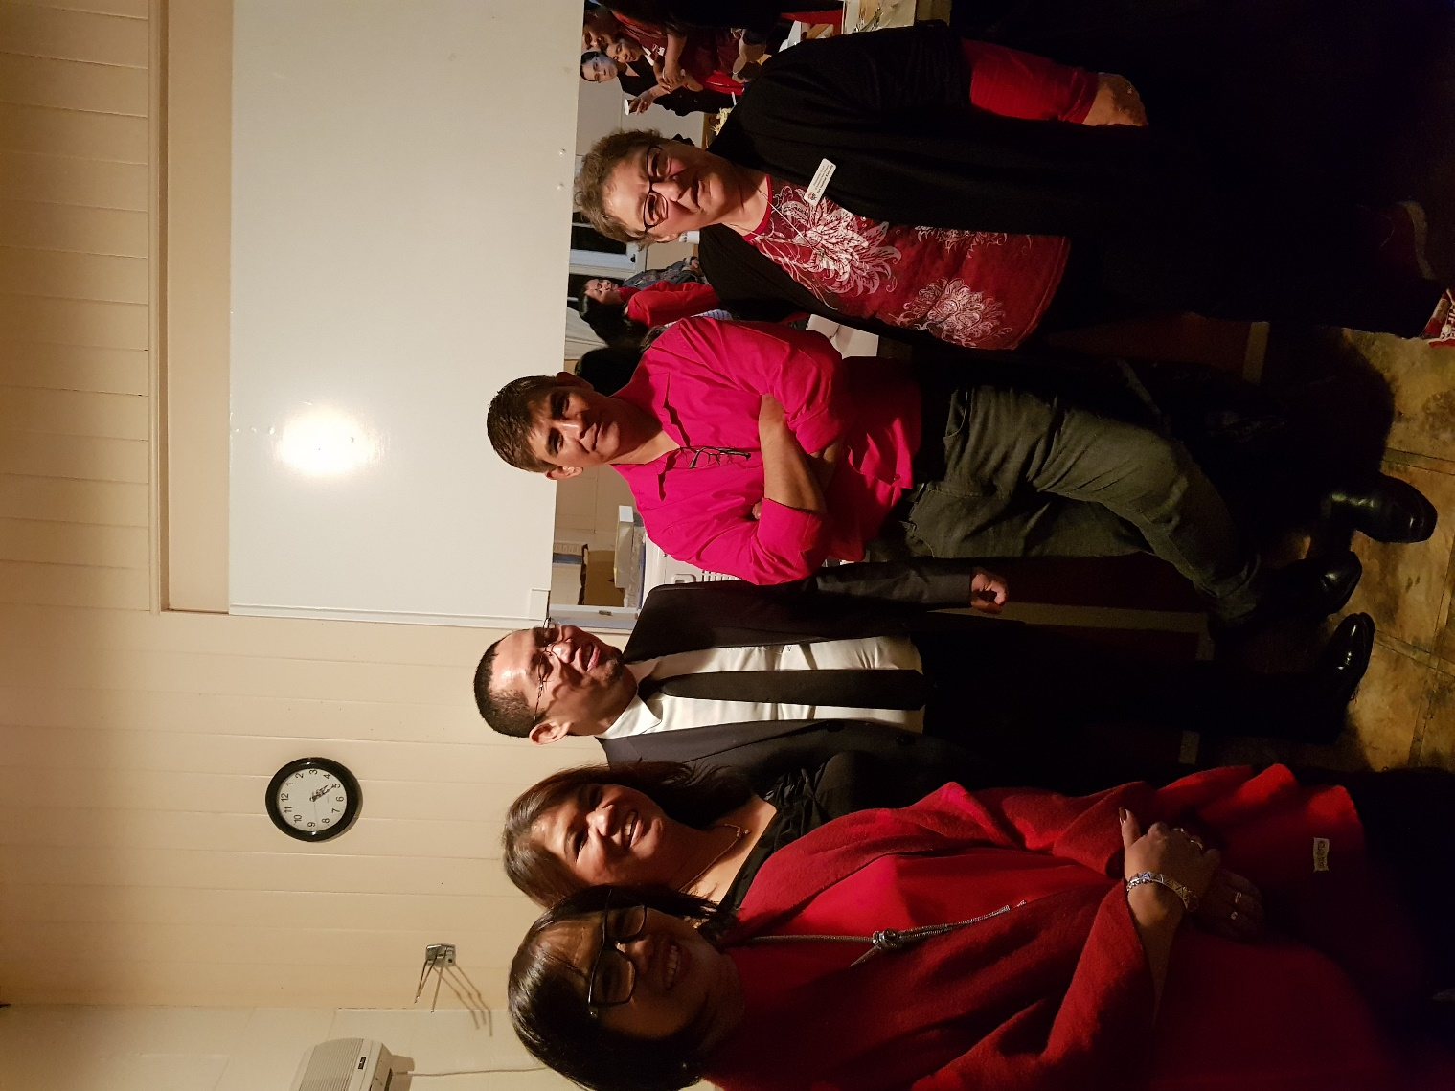We are also grateful to all of you who have been supportive to this ministry. Words are not enough for us to express how we feel. For all your prayer support and for accommodating us in the church.

All that has been done and being done at this time in the life of the Fellowship is all because God sustained it, provided for it and blessed it with faithful believers who work hand in hand in the fulfilment of God’s plan and purpose. We all give the glory to Him and Him alone.

* Teena Dela Cruz

**Photos from the celebrations held on Saturday 28th October.**

**Festive Hymn from Don Clearwater (2015)**

**Season All**

Tune: Away in a Manger

We praise you Lord Jesus for all that You were:

When we hear the story, the ‘gold and the myrrh’.

Now we give our presents to family and friends

Receiving and feasting, a joy He intends.

We love you, Lord Jesus, for all that You are;

The ‘Son of the Father’. Born under a star.

We knew that the pine tree, now glowing with light,

Will soon be a cross in the dark hour of night.

We thank you, Lord Jesus for all that you’ve done;

You gave us a life by the victory won.

The gift that You give us comes down as a dove,

For He is the reason; the season of Love.

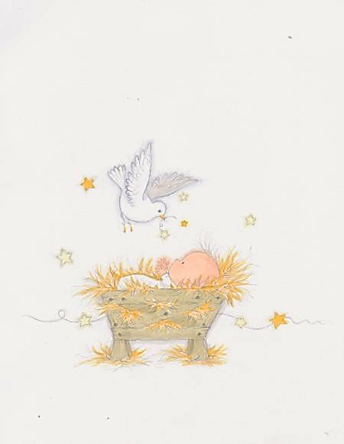

***A page for the children to colour-in***



Hint: The Jesus candle is white

The Joy candle is pink

The other candles are purple.

***Services & Events –***

***November 2017 to February 2018***

|  |  |  |
| --- | --- | --- |
| **November 2017** |  |  |
| Wednesday 1 Nov | 7.30pm | St. David’s Friendship group |
| Thursday 2 Nov | 7.00pm | Men’s Fellowship – Leeston Library |
| Saturday 4 Nov | 7.30pm | Lifetouch Fellowship |
| Sunday 5 November | 9.30am  11.00am  5.00pm  7.30pm | Communion Services  St. David’s, Leeston  Trinity, Dunsandel  Youth Pizza Café – Leeston  Brookside (Anglican) Service |
| Tuesday 7 Nov | 9.30am | Southbridge Home Group |
| Wednesday 8 Nov | 4.30pm | Working Bee at St. David’s |
| Thursday 9 Nov | 12.00 noon  2.00pm  7.30pm | Trinity Women’s Fellowship  St. David’s Afternoon Fellowship  Leeston Sector meeting |
| Friday 10 November | 7.30pm | Parish Council Think Tank  at St. David’s |
| Saturday 11 Nov | 9.30am to  12.00 noon | Parish Forum at St. David’s |
| Sunday  12 November | 9.30am  11.00am | Worship Services  St. David’s, Leeston  Trinity, Dunsandel |
| Thursday 16 Nov | 7.30pm | Dunsandel Sector meeting |
| Saturday 18 Nov | 7.30pm | Lifetouch Fellowship |
| Sunday  19 November | 9.30am  11.00am  7.30pm | Worship Services  St. David’s, Leeston  Trinity, Dunsandel (Anglican)  Brookside (Communion Service) |
| Thursday 23 Nov | 7.30pm | Parish Council at St. David’s |
| Saturday 25 Nov | 7.30pm | Lifetouch Fellowship |
| Sunday  26 November  (St. Andrew’s Day) | 9.30am  11.00am | Worship Services  St. David’s, Leeston  Café Church, Dunsandel |

|  |  |  |
| --- | --- | --- |
| **December 2017** |  |  |
| Friday 1 December | 5.00pm | Christmas Parade / Fete / Display |
| Saturday 2 Dec | 7.30pm | Lifetouch Fellowship |
| Sunday  3 December | 9.30am  11.00am  3.00pm  7.30pm | Communion Services  St. David’s, Leeston  Trinity, Dunsandel  Youth Pizza Café – Fereday’s Island  Brookside (Anglican) Carol Service |
| Tuesday 5 Dec | 9.30am | Southbridge Home Group |
| Wednesday 6 Dec | 12.00 noon | St. David’s Friendship  and Fellowship Groups combined lunch at Southbridge |
| Thursday 7 Dec | 7.00pm | Men’s Group, Leeston Library |
| Saturday 9 Dec | 7.30pm | Lifetouch Fellowship |
| Sunday  10 December | 9.30 am  7.30pm | St. David’s, Leeston (Christmas Play)  Community Carol Service at Dunsandel |
| Thursday 14 Dec | 10.00am | Trinity Fellowship at Sykes home |
| Saturday 15 Dec | 7.30pm | Lifetouch Fellowship |
| Sunday  17 December | 9.30 am  7.30pm | Worship Services  St. David’s, Leeston  Brookside service |
| Saturday 23 Dec | 7.30 pm | Lifetouch Fellowship |
| Sunday 24 December | 8.00pm  10.00pm | Worship Services  St. David’s, Leeston  Trinity, Dunsandel |
| Monday  25 December | 8.00am  9.30am | Christmas Day Services  Brookside  St. David’s, Leeston |
| Saturday 30 Dec | 7.30pm | Lifetouch Fellowship |
| Sunday 31 December | 9.30am | Combined Worship Service  Trinity, Dunsandel |

|  |  |  |
| --- | --- | --- |
| **JANUARY 2018** |  |  |
| Saturday 6 January | 7.30pm | Lifetouch Fellowship |
| Sunday 7 January | 9.30 am | Combined Service  St. James, Southbridge |
| Saturday 13 January | 7.30pm | Lifetouch Fellowship |
| Sunday 14 January | 9.30 am | Combined Service  St. John the Evangelist  Anglican Church, Leeston |
| Sunday 21 January | 9.30am | Combined Service  St. David’s, Leeston |
| Saturday 27 January | 7.30pm | Lifetouch Fellowship |
| Sunday 28 January | 9.30am | Worship Service  Hone Wetere, Taumutu |

|  |  |  |
| --- | --- | --- |
| **FEBRUARY 2018** |  |  |
| Thursday 1 February | 7.00pm | Men’s fellowship – Leeston Library |
| Saturday 3 February | 7.30pm | Lifetouch Fellowship |
| Sunday 4 February  Covenant Sunday | 9.30am  11.00am  5.00pm  7.00pm | Communion Services  St. David’s, Leeston  Trinity, Dunsandel  Youth Pizza Café  Brookside (Anglican) |
| Tuesday 6 February | 9.30am | Southbridge Home group |
| Wednesday 7 Feb | 2.00pm | St. David’s Friendship group |
| Thursday 9 Feb | 7.30pm | Leeston Sector meeting |
| Saturday 10 Feb | 7.30pm | Lifetouch fellowship |
| Sunday 11 February | 9.30am  11.00am | Worship Services  St. David’s Leeston  Trinity, Dunsandel |
| Wednesday 14 Feb | 2.00pm  2.00pm | St. David’s Afternoon Fellowship  Trinity Women’s Fellowship group |
| Thursday 15 Feb | 7.30pm | Dunsandel Sector meeting |
| Saturday 17 Feb | 7.30pm | Lifetouch Fellowship |
| Sunday 18 February | 9.30am  11.00am  7.00pm | Worship Services  St. David’s, Leeston  Trinity, Dunsandel (Anglican)  Brookside |
| Thursday 22 Feb | 7.30pm | Parish Council meeting - Brookside |
| Saturday 24 Feb | 7.30pm | Lifetouch Fellowship |
| Sunday 25 February | 9.30am  11.00am | Worship Services  St. David’s Leeston  Café Church at Dunsandel |

For all events please check for updates or alterations in the Weekly Bulletins as times and dates may change.

**Small Groups for all ages!**

|  |  |  |
| --- | --- | --- |
| **Groups for Adults** | |  |
| **Intercessory Prayer** | 7.00pm | Every Tuesday, at St. David’s, Leeston, note: last Tuesday of month at Trinity Church, Dunsandel.  *Contact Mandy, ph: 324 2225* |
| **Southbridge Home Group** | 9.30am | 1st Tuesday of the month at Ruth’s home in Southbridge.  *Contact Janice, ph: 324 8202.* |
| **St. David’s Friendship**  **Group** | 2.00pm | 1st Wednesday of the month at various homes.  *Contact Hilary, ph: 324 3823.* |
| **St. David’s**  **Afternoon**  **Fellowship** | 2.00pm | 2nd Thursday of the month at the Church.  *Contact Janice, ph: 324 8202.* |
| **Trinity**  **Women’s**  **Fellowship**  **Group** | 2.00pm | 2nd Thursday of the month at Trinity Church, Dunsandel.  *Contact Mavis ph: 325 4142.* |
| **Lunch Bunch** | 12.00 noon | A Dunsandel Trinity initiative – 1st Thursday of the month at various local eateries.  *Contact Mavis ph: 325 4142.* |
| **Men’s Group** | 7.00pm | 1st Thursday of month at Community Room, Leeston Library.  *Contact Michael ph: 324 2225.* |
| **Lifetouch Fellowship** | 7.30pm | Ministry for Filipino families and others.  Worship Service every Saturday. *Contact Teena, ph: 324 2240 or 021 081 62926.* |

|  |  |  |
| --- | --- | --- |
| **Groups for Children & Youth** | | |
| **Children’s**  **Ministry** |  | During worship each Sunday during the school term in Leeston.  *Contact Lois ph: 324 3884* |
| **Pre-school Music** | 9.45am –  10.30am | Wednesdays at St. David’s Church Sunday School room, followed by coffee and chat for parents and caregivers.  *Contact Naomi ph: 324 4075.* |
| **Youth Pizza Café** | 5.00pm –  7.00pm | 1st Sunday of the month at St. David’s Church, Leeston.  *Contact Linda ph: 324 2166 or Kath ph:*  *324 4100.* |

|  |
| --- |
| **Deadline for next newsletter - 15 February 2018**  **Contact person - Rev. Heather Kennedy**  Please send your information by email to [rev.heather.kennedy@gmail.com](mailto:rev.heather.kennedy@gmail.com) by the deadline date. |

|  |  |
| --- | --- |
| **CONTACT DETAILS** |  |
| **Minister** | **Phone** |
| Rev. Heather Kennedy | 324 3315 |
| **Email** | rev.heather.kennedy@gmail.com |
| **Website** | [www.churchatellesmere.org.nz](http://www.churchatellesmere.org.nz/) |
| **Lifetouch Pastor** |  |
| Teena Dela Cruz | 324 2240 |
| **Senior Laypersons** |  |
| Paul Birkett | 324 3884 |
| Robbie Stewart | 325 4535 |
| **Pastoral Care** |  |
| Lois & Paul | 324 3884 |
| Janice | 324 8202 |
| Robbie | 325 4535 |
| Noel | 329 1877 |



**Seasons Greetings to you all.**